Group Name: Alpha
Group Members:
Perla Garcia Cavazos
Dallas Baldwin
Jose Rodriguez
Orlando Camacho
Kristian Wareing

Case Study Selected: Bacchus Winery
7/19/2026
Module 9.1
Assignment: Milestone #2

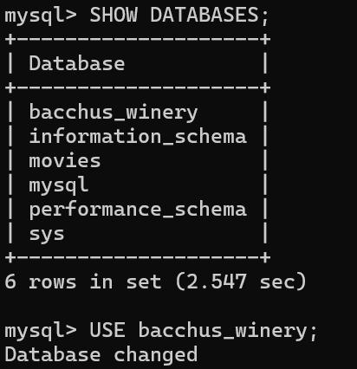
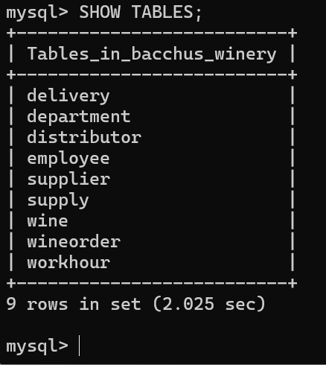
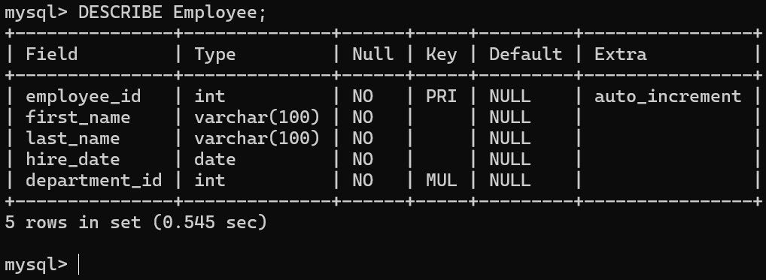
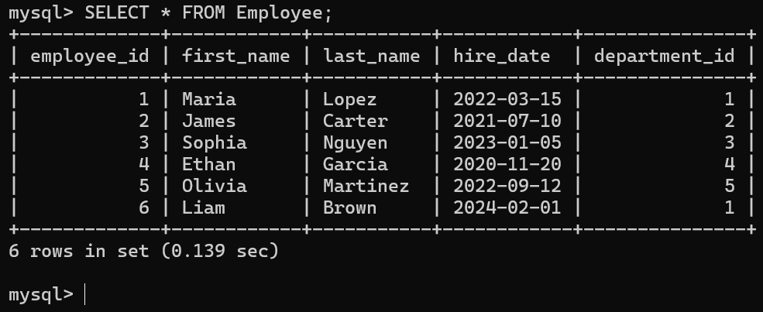
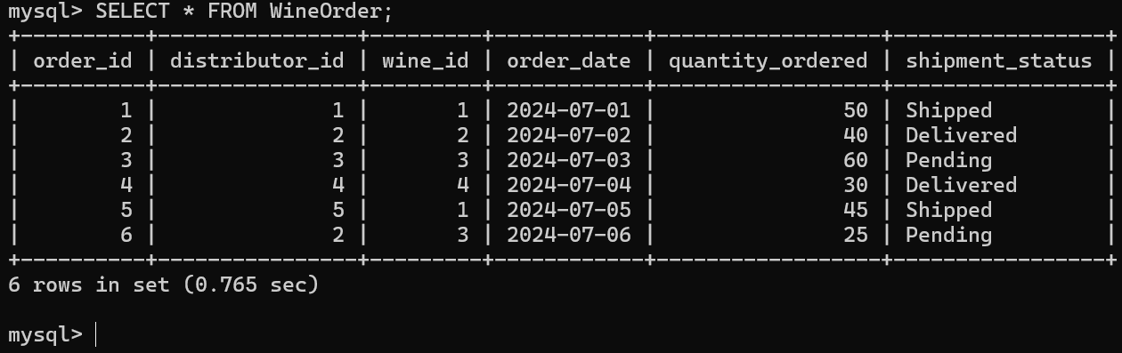
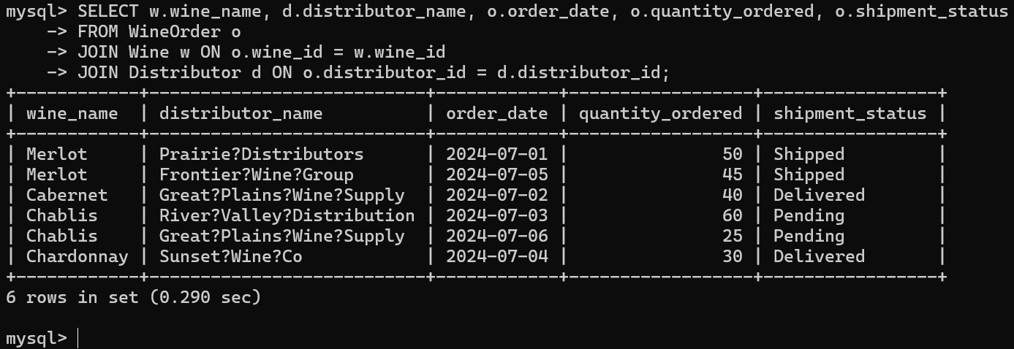

EMPLOYEE / DEPARTMENT / WORK HOURS

Department
- Department _id (PK)
- Department _name
Employee
- Employee _id (PK)
- First _name
- Last _name
- Hire _date
- Department _id (FK → Department. department _id)
Work Hour
- Workhour _id (PK)
- Employee _id (FK → Employee. Employee _id)
- Work _date
- Hours _worked
Relationships:
- One Department → Many Employees
- One Employee → Many Work Hour records

SUPPLIER / SUPPLY / DELIVERY
Supplier
- Supplier _id (PK)
- Supplier _name
- Contact _phone
- Contact _email

Supply
- Supply _id (PK)
- Supply _name
- Supply _type
- Supplier _id (FK → Supplier. Supplier _id)
Delivery
- Delivery _id (PK)
- Supplier _id (FK → Supplier. Supplier _id)
- Expected _delivery _date
- Actual _delivery _date
Relationships:
- One Supplier → Many Supplies
- One Supplier → Many Deliveries

WINES / DISTRIBUTORS / ORDERS
Wine
- Wine _id (PK)
- Wine _name
- Wine _type
- Price _per _case

Distributor
- Distributor _id (PK)
- Distributor _name
- Contact _phone
- Contact _email

Wine Order
- Order _id (PK)
- Distributor _id (FK → Distributor. Distributor _id)
- Wine _id (FK → Wine. Wine _id)
- Order _date
- Quantity _ordered
- Shipment _status

Relationships:
- One Distributor → Many Wine Orders
- One Wine → Many Wine Orders
- Many-to-Many between Wine & Distributor is resolved through Wine Order

Business Rules
- Bacchus Winery employs multiple employees.
- Each employee works in exactly one department.
- Each employee may have multiple work-hour records.
- Each work-hour record belongs to one employee and records the date and hours worked.
- Bacchus Winery purchases supplies from three suppliers.
- Each supplier may provide multiple types of supplies.
- Each supply delivery belongs to one supplier.
- Each delivery records an expected delivery date and an actual delivery date.
- Bacchus Winery produces four wines: Merlot, Cabernet, Chablis, and Chardonnay.
- Bacchus Winery sells wine to multiple distributors.
- Each distributor may order multiple wines.
- Each wine may be ordered by multiple distributors.
- Each wine order records the distributor, wine, order date, quantity ordered, and shipment status.
Assumptions
- Each employee belongs to only one department.
- Employee hours are entered by work date.
- Each supplier delivery may contain multiple supply items, but the ERD tracks the delivery as a whole.
- The winery has only the three suppliers described in the case study.
- Each wine order represents one wine ordered by one distributor.
- The same distributor may place multiple orders for the same wine.
- Shipment status uses values such as Pending, Shipped, or Delivered.

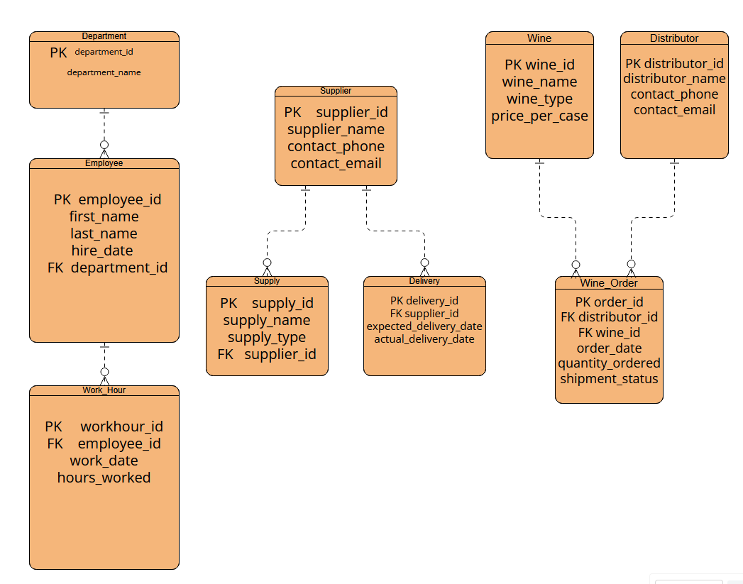
Milestone #2 – Data Displayed from Tables
The following screenshots show the output of the Python script (DisplayData.py), which connects to the bacchus_winery MySQL database and displays every record in each table.
Screenshot 1 of 2:
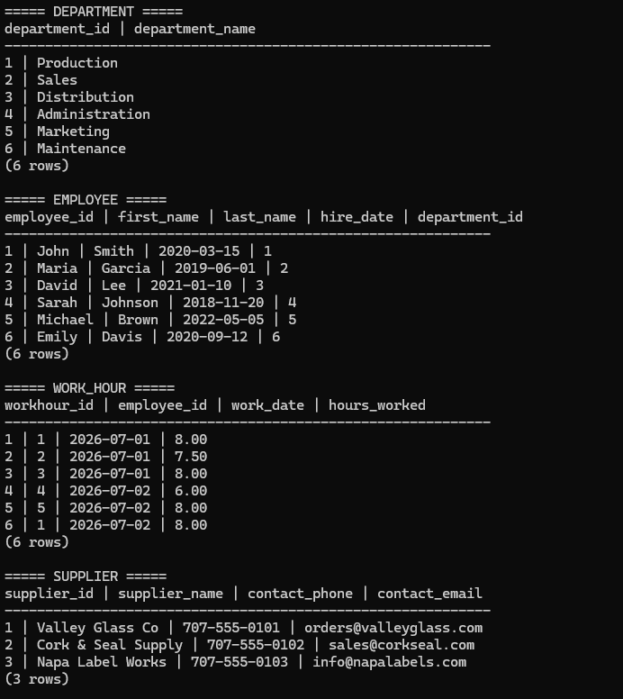
Screenshot 2 of 2:
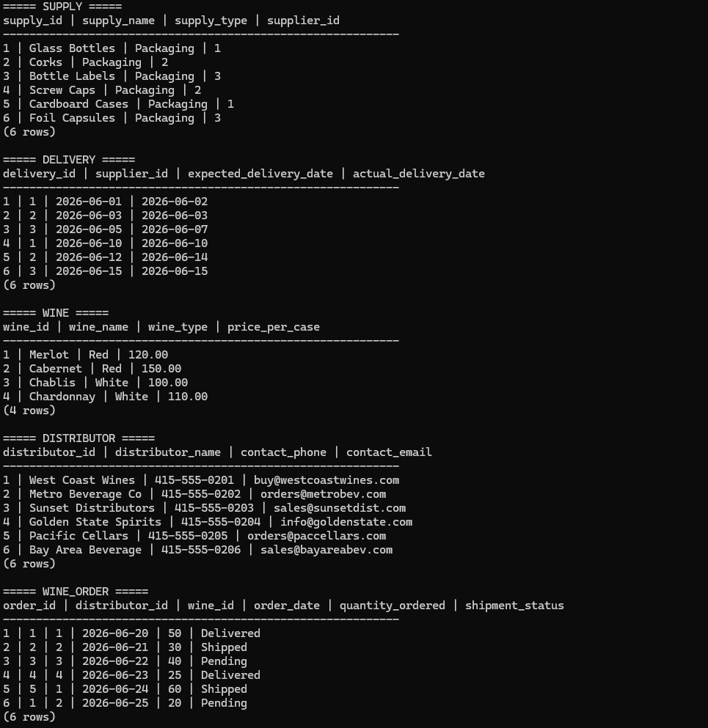

Case Study Selected: Bacchus Winery
7/19/2026
Module 9.1
Assignment: Milestone #2

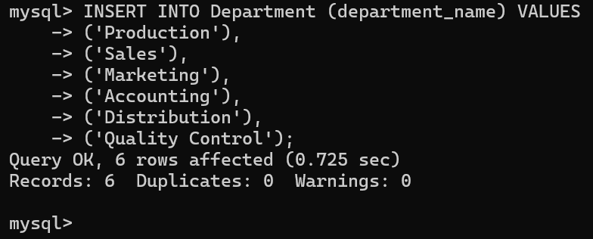
Screenshot 1: Successful Department table insert — 6 rows added.
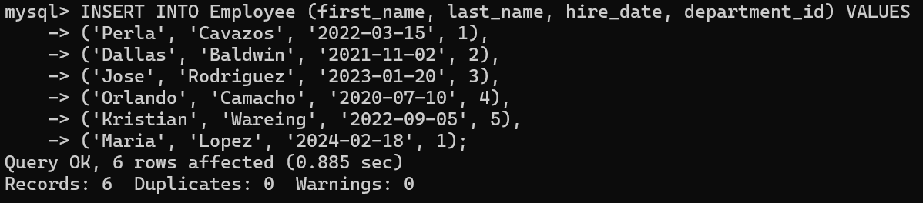
Screenshot: Employee table successfully populated with 6 records using valid department IDs.
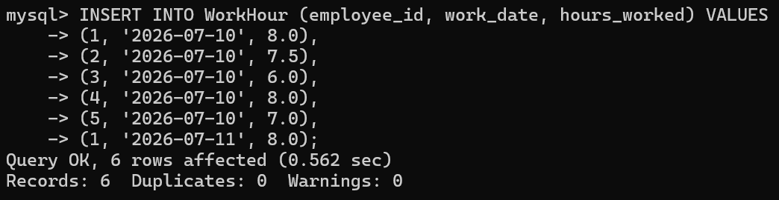
Screenshot: Work Hour table successfully populated with 6 records linked to existing employees.
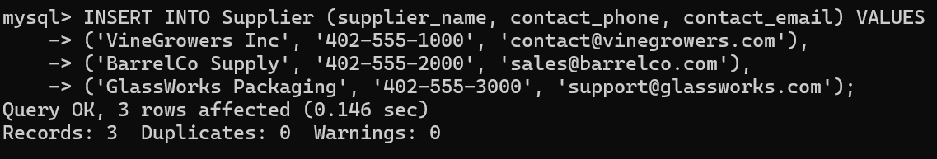
Screenshot: Supplier table successfully populated with 3 records as required by the case study.
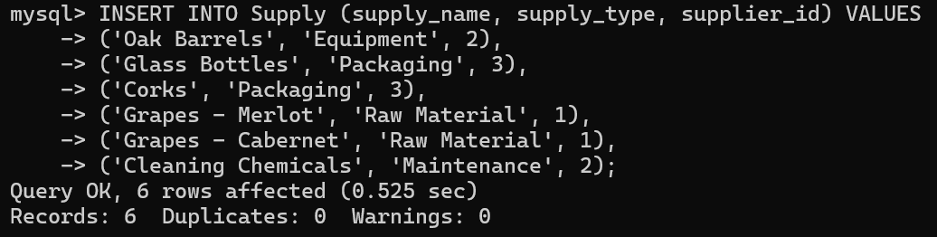
Screenshot: Supply table successfully populated with 6 records linked to valid suppliers.
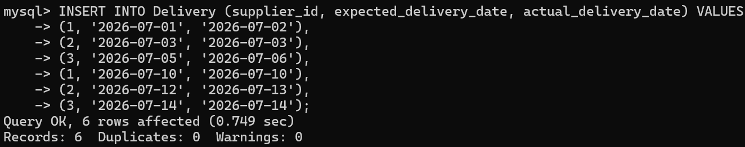
Screenshot: Delivery table successfully populated with 6 delivery records showing expected and actual dates.
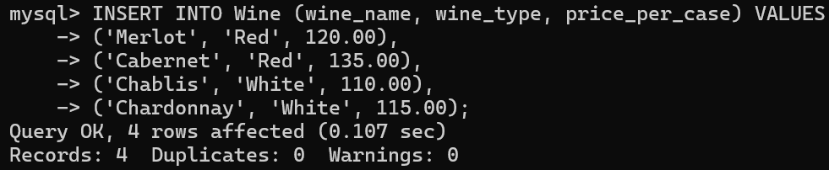
Screenshot: Wine table successfully populated with 4 wine records as specified in the case study.
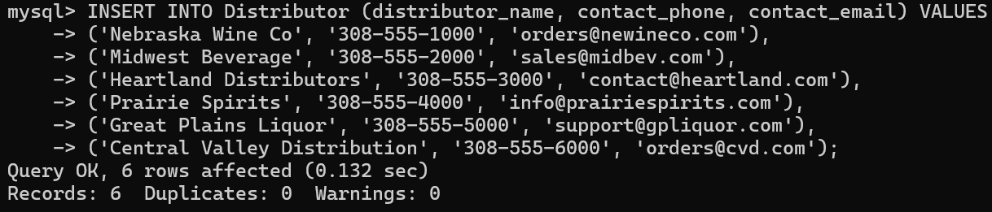
Screenshot: Distributor table successfully populated with 6 distributor records.
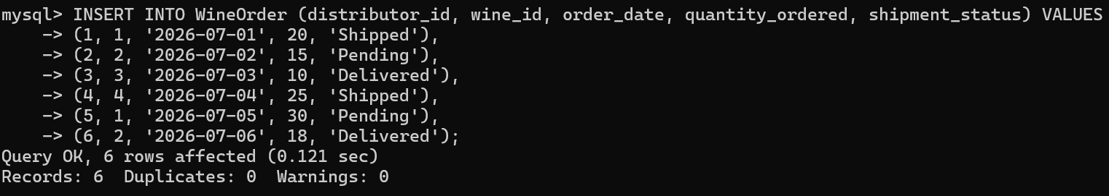
Screenshot: Wine Order table successfully populated with 6 records linking distributors and wines.

